

**TEAM WORK**



TEAM MEMBERS

1. Ahmed Hesham Ismael (Team Leader)
2. Nagwa Ali Mohammed

* ***Programming Languages Used :***

1. **HTML**
2. **CSS**
3. **JavaScript**
4. **PHP**
5. **Ajax**

* ***Libraries & Frameworks & Platforms:***

1. **jQuery**
2. **Laravel**
3. **Bootstrap**
4. **App.js**
5. **Fontawesome**

PROJECT

Website

Responsive

Secure

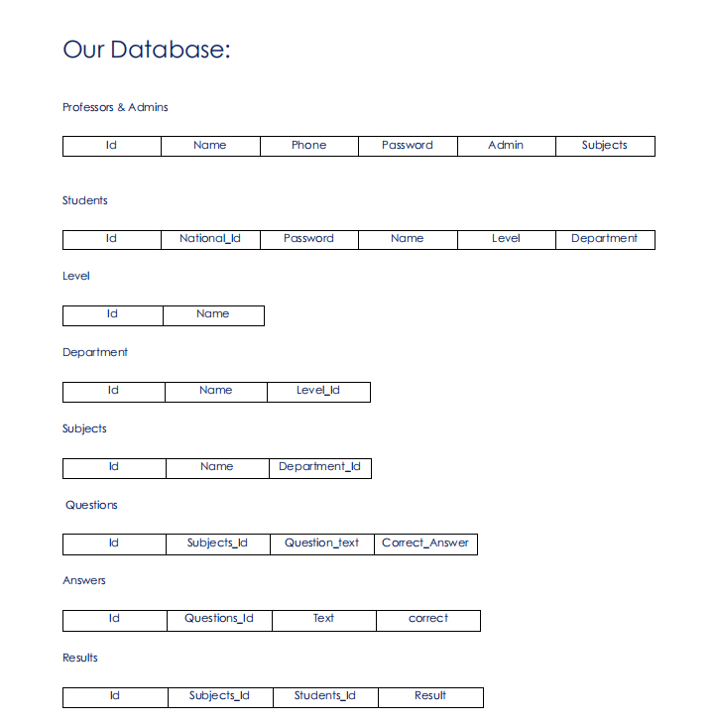

**DIfficults:**

|  |  |
| --- | --- |
| **Id** | **Name** |

**Chapters:**

|  |  |  |
| --- | --- | --- |
| **Id** | **Name** | **Subject_id** |

**Requests:**

|  |  |  |  |
| --- | --- | --- | --- |
| **Id** | **Name** | **Phone** | **Password** |